Offered by Holy Child Associate Linda Tarney, American Province

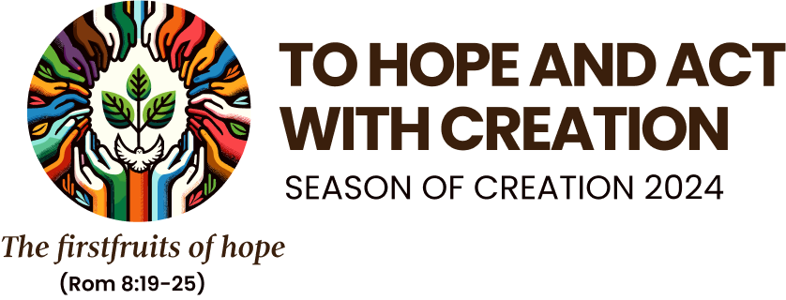

This year’s Season of Creation theme—“to hope and act with Creation”—connects beautifully with the Society’s mission, “to rejoice in God’s presence and to help people believe that God lives and acts in them and in our world.”
Our actions and loving responses to God’s creation brings hope to all in the Cosmos, as we are interdependent and interconnected.
Imagine a small child squatting down to look for wild strawberries among the grasses behind her swing set. She is unaware that God brought forth these edible plants with the help of pollinators, the sun, and the rain to turn the white strawberry flower into nourishing fruit for insects, bunnies, and the little girl.
Hope brings to mind the phrase attributed to St. Augustine: “Hope has two beautiful daughters: their names are Anger and Courage. Anger at the way things are, and Courage to see that they do not remain as they are.”
With the Incarnation of God’s Son guiding us, let our holy anger give us courage to be hopeful and active for justice for all creation.
Where do you see hope for your future in God's miraculous Cosmos?

